IBudget

Software Quality Assurance Plan

Part 2 of 2 developed by Laurene A.

Approvals: V. Dineva date: C. Leung date:
Q. Pham date:
V. Velev date:

J. Reimels date:

The table of contents of this SQAP follow that of IEEE standard 730-1989.

8. Problem reporting & corrective action

[Note to the student: this section explains how defects come to be recognized, described and repaired. They do not follow the details of IEEE standards. The reader is referred to the IEEE standards, as well as to Humphry [Hu] for further defect severity and type classifications.]

The Problem Reporting Form to be used by the ITeam in response to a software problem report generated by QA is shown in figure 2.55.

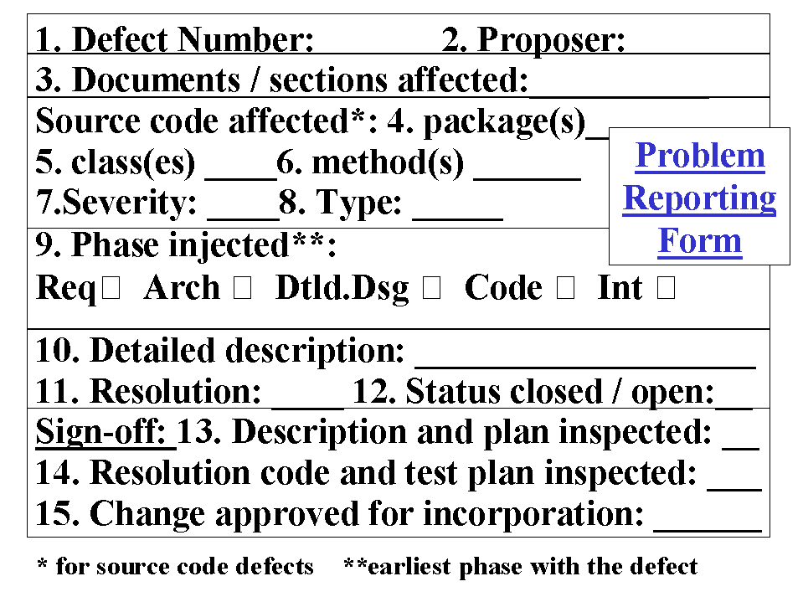
Figure 2.55 Problem Reporting Form Example

To use this form, the members of the team should fill the describeDefect form on directory QA on the Google Code repository.

The values for severity are as follows.

Major: results in a requirement not satisfied

Trivial: will not affect the execution of the application or its maintenance

Minor: neither major nor trivial

The members of the team are not encouraged to create defect reports for trivial defects, but to send e-mail to the leader of the affected section who will most likely to be in a position to repair the defect or to send it to the member who is most qualified.

The values for documentation defect type are missing material, unclear, ambiguous, incomplete, redundant (within or between documents), and contradictory.

The values for code defects type are syntax, logic, data (i.e., allows a wrong variable value), insecure (allows unacceptable security breach).

When a member of the team resolves a defect, he must put the defect’s status to closed. The QA leader must check the filled forms in the QA/Defects folder on a weekly basis and move the ones with a closed status to the QA/FixedDefects folder.

When defects are not fixed within a certain period of time the team leader is notified by the QA leader and has to make the appropriated decision.

The QA leader must either write or assign another member to write a weekly report about the defects (most important defects, global situation…).

9. Tools, techniques and methodologies

SQA techniques include the auditing of standards, requirements tracing, design verification, software inspections and the verification of formal methods. The SQA tools consist of mainly checklists. Checklists include the following.

• Review checklists are used at formal meetings, for document reviews and for inspections.
• Checklists will be used for verifying the quality of the following activities and documents: Preliminary Design Review, Critical Design Review, Test Readiness Review, Functional Configuration Audit, Physical Configuration Audit, SRS, SDD, SPMP and Software Development Folders.
• Separate checklists and forms are used for software audit purposes.

10. Code control

The methods and facilities used to maintain, store, secure and document versions of completed code during all phases of the software life cycle are specified in the SCMP. The SQA team verifies that the code control procedures specified in the SCMP are followed.

The QA team will give out formal tests in a checklist for the implementing team to execute to check if their code respects the quality standards. The developer will have a few days to fill the checklist and give the results to the QA leader.

If the results are not conclusive, the QA leader will work with the developer to change the code that has not respected the quality standards defined before.

11. Media control

[Note to the student: Describe the means by which disks, tapes, floppies will be managed.]

The SQA team verifies that the software media are built and configured per the SCMP and that authorized changes have been installed and tested. In addition, the SQA team verifies that the software media are duplicated using only the procedures identified in the SCMP. The SQA audit reports for media control are intended as further evidence that QA procedures have been followed.

12. Supplier control
[Note to the student: this section concerns relationships with suppliers of software and hardware. It describes how and by whom these relationships are to be handled. The SQA team verifies commercial off the shelf (COTS) products provided by the suppliers these during incoming inspection, by reviewing the packing slips that identify the product and its version number. The products are validated through installation and acceptance tests.]

For this project, there will be no suppliers to deal with. The software used is Open
Source and can be downloaded on the internet freely.

13. Records collection, maintenance &
retention

[Note to the student: this section describes how, physical records will be handled, and who are responsible. Include disk files that are not under configuration control.]

The SQA records collected and archived shall include:

• task reports,
• anomaly reports not handled by the regular problem reporting mechanism,
• memos, including recommendations to responsible parties,
• logbooks of SQA activities,
• audit reports,
• signed-off checklists from reviews and audits
• signed-off checklists from defects handling, formal tests

Besides verifying the archive procedures specified in the SCMP, SQA shall separately archive its own records at least once a week. These records are retained throughout
the operation and maintenance phase.

14. Training

[Note to the student: SQA training specific to this project.]

The QA team will do a quick presentation of the metrics to be used, the forms to fill when finding a defect. At the beginning of each activity, the QA team will also inform the team about the quality aspects of the activity.
At the beginning and during the development, the QA team will expose examples of formal tests that have to be done at some point of the development in order to show the developers how to execute them.

15. Risk Management

SQA team members are encouraged to identify risks as early as possible. The procedures for risk management are specified in section 3.3 of the SPMP.

